**Assignment-1**

Explain the role of continuous monitoring in DevOps and demonstrate the use of Nagios as a continuous monitoring tool by configuring a host machine with Nagios server.

**Role of continuous monitoring in Devops:**

**Continuous monitoring** basically assists IT organizations, Devop teams in practice that provides the roles of an organization. Continuous monitoring (CM) , sometimes called Continuous Control Monitoring (CCM), is an automated process by which Devops can play an important role and Devops personnel can observe and detect compliance issues and security threats during each phase of the Devops pipeline.

Continuous monitoring provides real-time data approach and hybrid environments , and will notify Dev and QA teams in the event of specific issues arising in the prod environments. Thereby, it provides feedback on what is going wrong, which allows the relevant people to work on necessary fixes as soon as possible.

It also provides general feedback on the overall health of the IT setup, including offsite networks and deployed software.

**Goals:**

1. Enhance transparency and visibility of IT and network operations, especially they can trigger a security breach and resolve it with a well-timing alert system.
2. Helps to monitor software operation, i.e., performance issues, identify the cause of the error, and apply solutions to those issues.
3. Helps to track the behavior, i.e., after the update to a particular application has been pushed to the prod team. This monitors the update whether it is working fine in all aspects.

Types of Continuous monitoring :

1. Infrastructure monitoring
2. Application monitoring
3. Network monitoring

**Infrastructure monitoring:**

Monitors all the IT infrastructure and manages the IT aspects and sectors which are required to deliver the products and services. This includes data centers, networks, hardwares, softwares, services, storages,servers etc. It monitors and examines the data from the IT ecosystem to improve product performances.

**Application monitoring:**

Monitors all the performances of released softwares (Applications) based on the metrics such as functioning of routers, switches, Virtual Machines etc and manages the stability of the back-end and front- end supports.

**Network monitoring:**

Network plays an important role in IT Devops domain which monitors and tracks the network activity, including the speed and performance of the network and status, functionality of the network firewalls, switches etc. Network monitoring detects the issues and alerts from the relevant source.

The primary goal is to prevent the network downtime and crashes.

Benefits:

1. Better network visibility and transparency
2. Facilitates rapid responses
3. Minimize system Downtime
4. Assists with system performance
5. Management of 3 teams - QA, release and prod teams in Devops domain

Risk management sector plays a vital role in Devops Strategy and that will implement an appropriate system to the risk management system.

Facilitates the understanding of the matrices in devops for the strategies that will reduce the compliance to the strategy , depending on the nature.

**Use of Nagios as a continuous monitoring tool by configuring a host machine with Nagios server:**

Nagios is an open source tool and monitoring tool for computer systems. It was designed to run on Linux operating systems and can monitor the Devices running Linux, Windows, Unix operating systems.

Nagios software that runs on periodic checks on critical applications parameters, network and server applications.

Nagios can monitor running usage of CPU, disk, memory and microprocessor load and other services.

* In the linux operating system, we use **Nagios XI** (an extended version of Nagios core, intended as the enterprise version of the monitoring tool).
* Nagios XI acts as monitoring software, configuration management and toolkit.
* Nagios is a free , XI must be license based tool which has a free trial version that adds a preconfigured Virtual Machines (VMs), a web configuration user interface (UI) , performance graphing, a monitoring in the mobile applications, and technical support through mail.
* It has a Nagios dashboard and logs that provides and checks whether the application is running or not.

Status of the Nagios in VM:

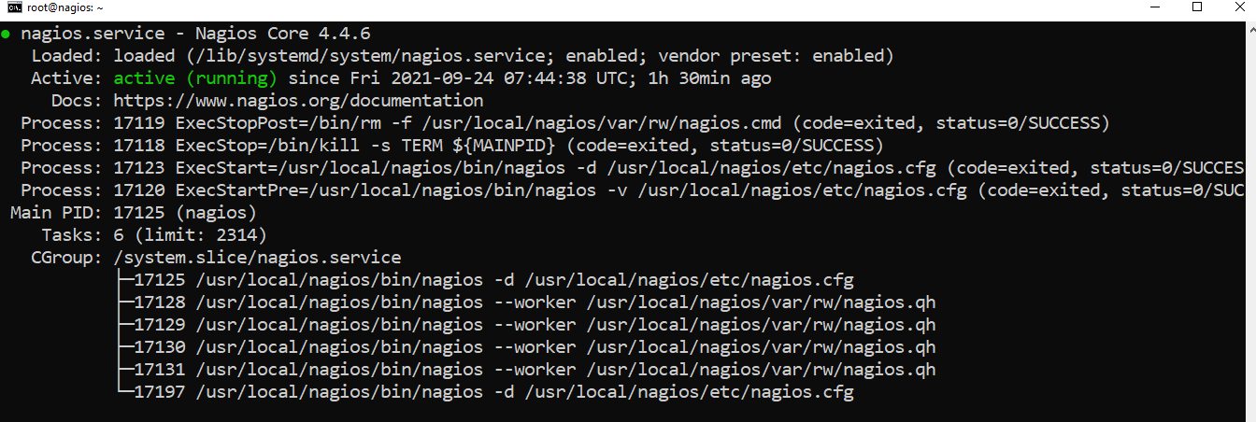

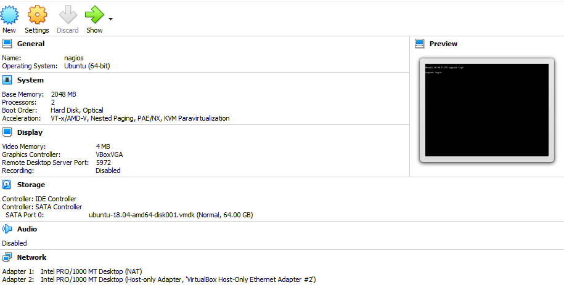

It can be accessed on 192.168.56.101.

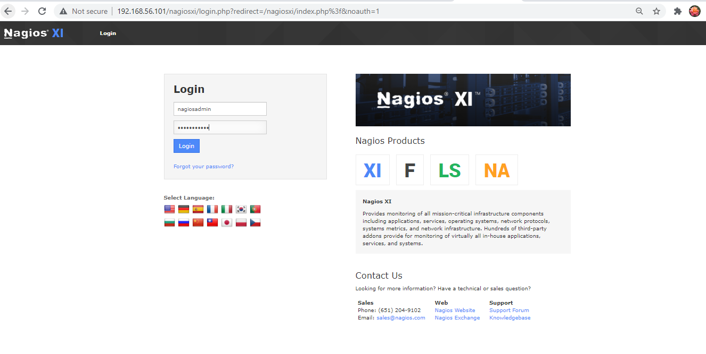

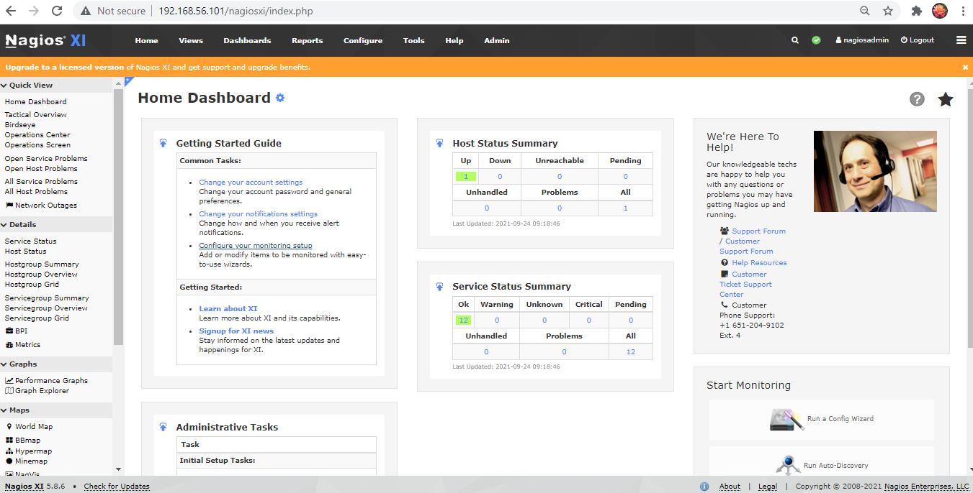

In the Home Dashboard of Nagios, it has Host status Summary and Service Status Summary.

